|  |
| --- |
|  |
| People & Problems |
| A Study in Finding Meaningful Products for Real People |

|  |
| --- |
| Claudine Dimalanta |

**Personal Business Objectives**

**Personal Business Objectives**

For a business to make it worth doing, it would require these to consider:

* **Income** – A comfortable income would be required. Something between $50k to $80k annually.
* **Lifestyle** – Preferably a business that allows me to work from home. Additionally, must be something I can be happy getting out of bed for.
* **Work/Life Balance** – A balance that keeps my sanity intact is important. If I’m enjoying my work to the fullest, I don’t mind a larger work ratio.
* **Opportunities to Serve** – I would want a business where I’m able to work personally with customers for the benefit of everyone involved.
* **World Outlook** – I don’t necessarily need a business that’s going to benefit the world.

**Opportunity Identification: People**

**4 Peer & Passion Groups**

**Peer Groups:**

* UVU Digital Media Students
* Freelance Graphic Designers
* Morkiepoo Owners
* Utah Cosplayers

**Passion Groups:**

* Adults with Polycystic Kidney Disorder (PKD)
* People in Need of Emotional Support Animals (ESA)
* Children in Poorly Equipped Schools
* Graduates Unable to Find Jobs Out of College

**4 Engaged Groups & Profiles**

* **Adults with PKD**
  + Polycystic Kidney Disorder affects adults ages 30-50, and both men and women equally. While PKD is a genetic disease, chances heavily increase in those that engage in drinking and smoking regularly. There are 100-250 cases in the US every year with 12 million affected worldwide.
* **Utah Cosplayers**
  + It’s estimated that 64% of cosplayers are female. Additionally, 60% of cosplayers are somewhere between 23-29 years old. It’s typical for cosplayers to search for deals on materials since costumes can become expensive easily. There are an estimated 15,000 cosplayers in Utah alone.
* **Graduates Unable to Find Jobs Out of College**
  + It’s estimated that in the US, out of all graduates age 25 and up, 3.8% of them are out of a job. Typically, these graduates aren’t as proactive in their search and often get trapped applying to one position and waiting.
* **Freelance Graphic Designers**
  + Of all freelance graphic designers in the U.S., 60% are female. They’re tech savvy and creative. Out of the 250,000 graphic designers in the U.S., 24% of them are self-employed. California, New York, & Texas have the highest number of graphic designers.

**Opportunity Identification: Problems**

**Meaningful Problems**

**Adults with PKD**

* There is no known cure for Polycystic Kidney Disease currently.
* Waitlists for organ donors can be long.
* Many additional health complications alongside PKD.
* Can easily go undetected for a long time

**Utah Cosplayers**

* Trouble finding affordable fabrics and props
* Trouble bringing repair items during conventions
* Trouble finding high quality costumes locally
* Trouble with wig styling

**Graduates Unable to Find Jobs Out of College**

* Sometimes forced to rely on relatives for support.
* Difficulty getting their foot into the industry.
* Often difficult to make connections after college.
* Can be unsure of what steps to take while being without guidance.

**Freelance Graphic Designers**

* They are susceptible to creative burnout.
* Can have difficulty with staying on top of deadlines.
* May have difficulty finding clients due to being freelance.
* They can quickly fall behind in work if they’re not fast enough.

**Problem Assessment Matrix (PAM)**

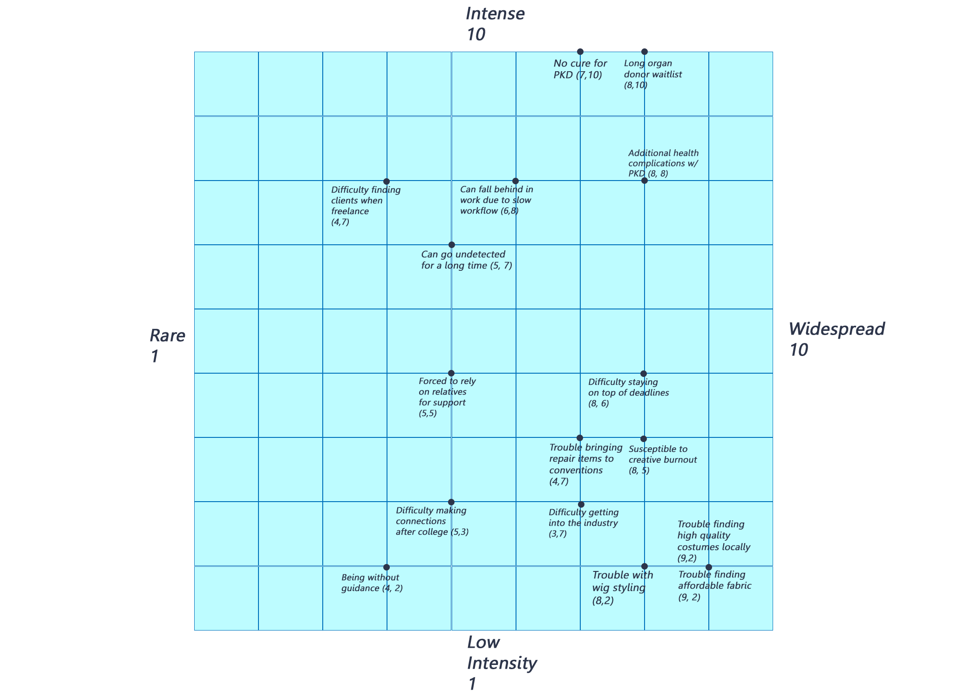

**2 Most Meaningful Problems**

1. **Waitlist for organ donors can be fatally long**

Talking with polycystic kidney disease patients, I discovered I was correct in assuming waitlists for organ donation is a major problem. Most patients unfortunately must undergo dialysis while in search of medical care. Due to an increase of organ shortage in the last few years, some patients are even in fear of dying while they wait. PKD patients are very much willing to pay for a solution that works considering the disease has no known cure.

1. **Additional health complications**

Alongside PDK comes a multitude of other health issues such as kidney stones, UTIs, risk of brain aneurysms, colon problems, and chronic pain. Discussing these with PDK patients, chronic pain was the biggest issue most had. Although these health complications are an issue, they can be managed. A difficult process in lessening the damage of PDK often comes with dramatic lifestyle changes.